Computer Vision HW8

資工碩一 胡嘉祐 R07922162

1. Principle code

Part 1. Generate additive white Gaussian & noise salt-and-pepper noise

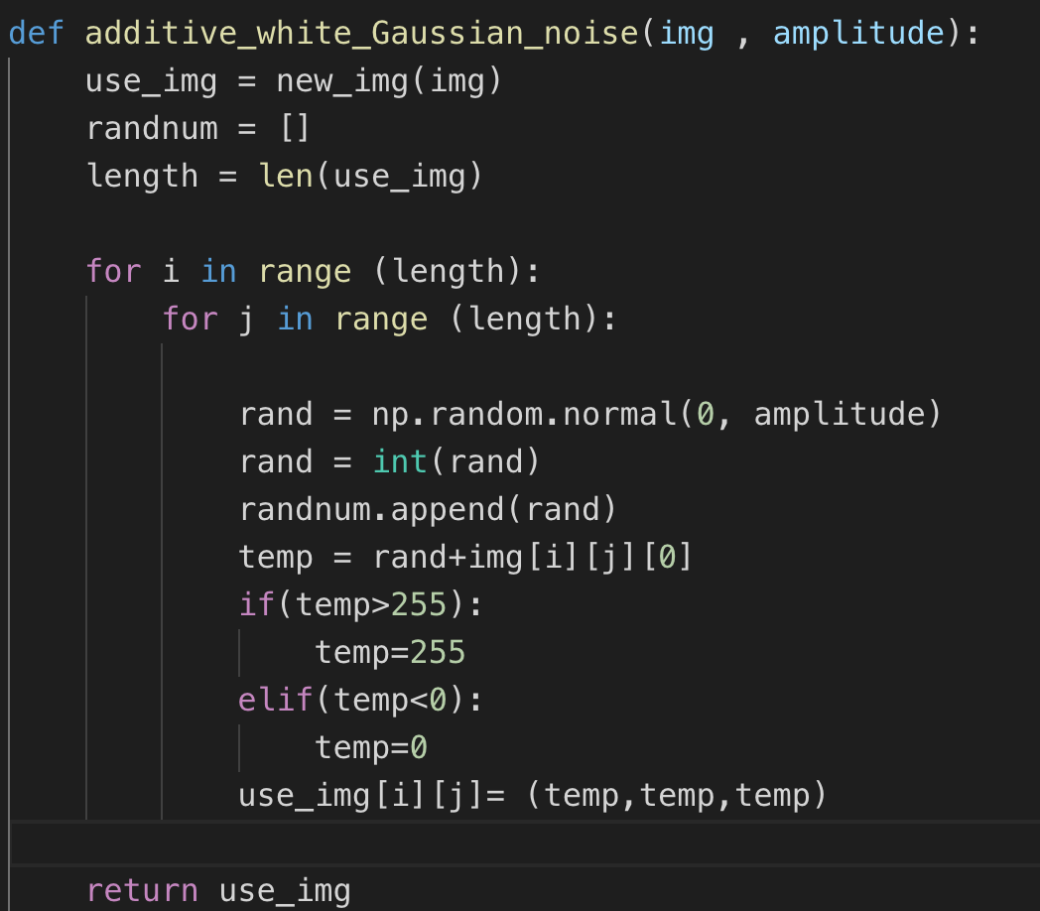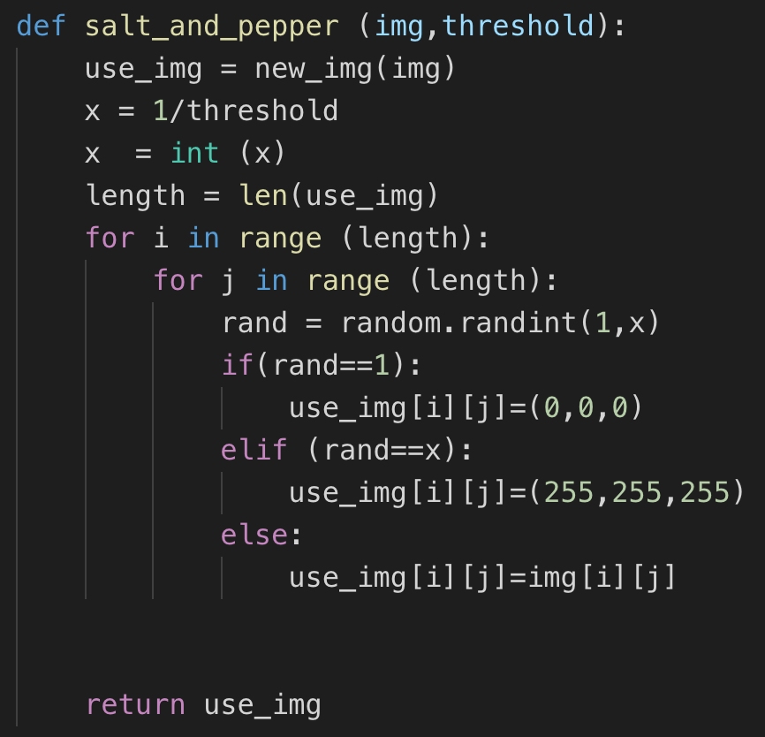

Part 2. Box filter and Median filter

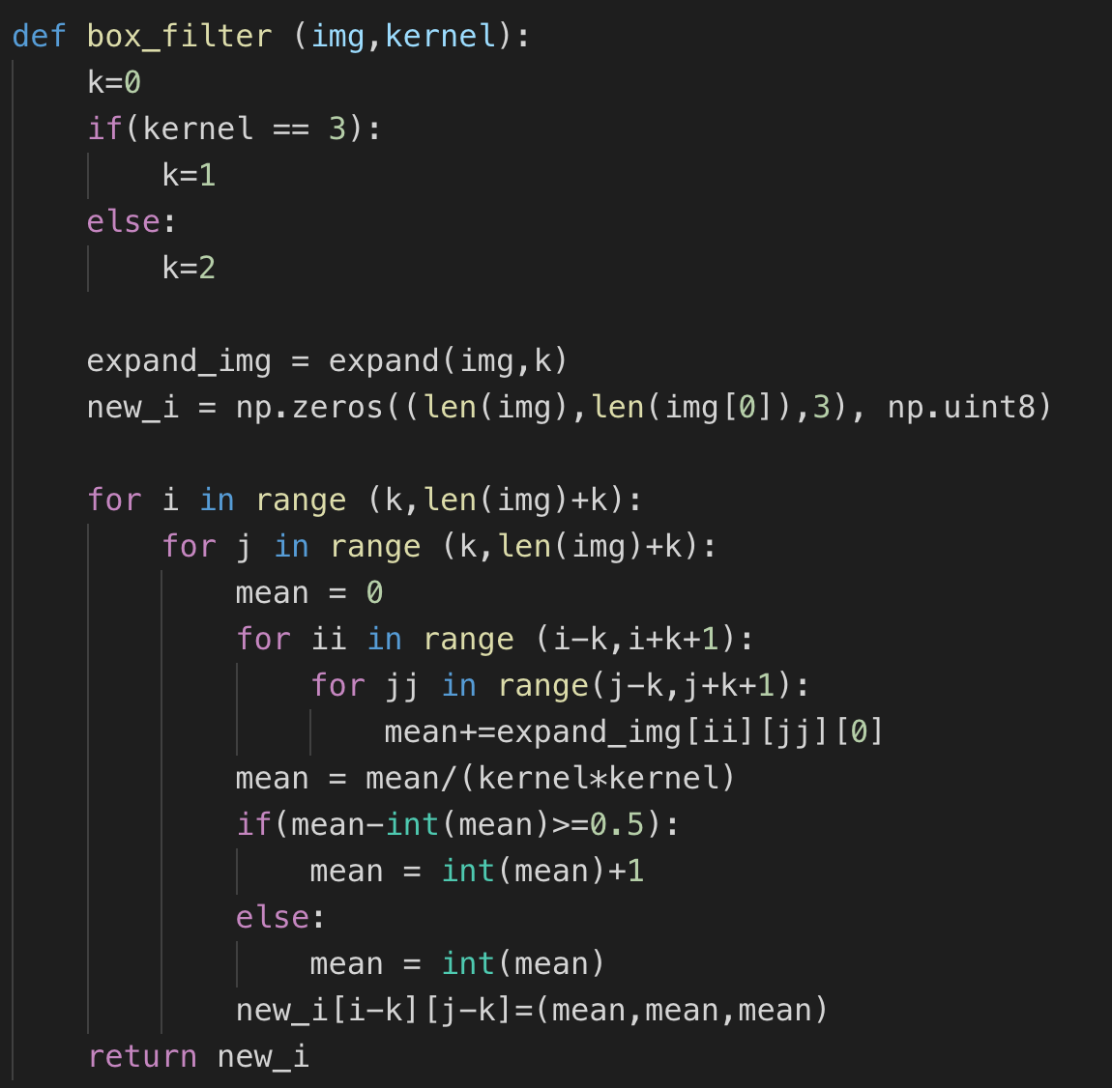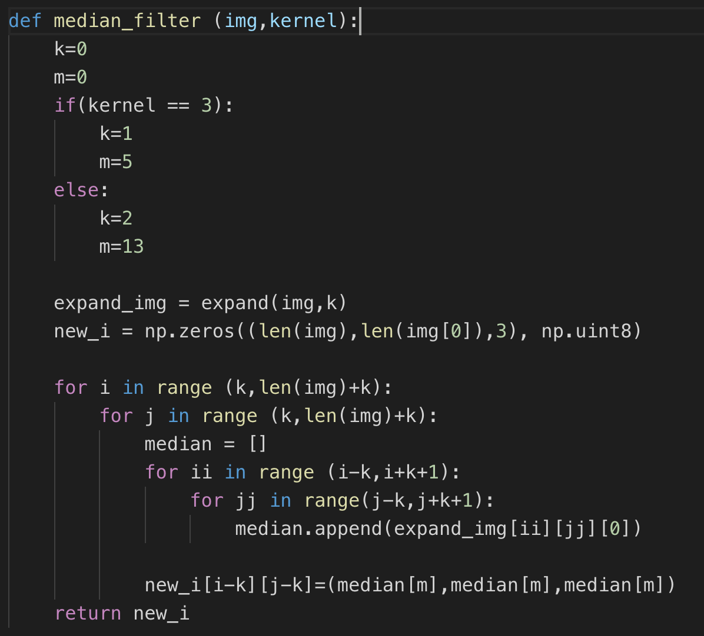

2. Result

part 1 four Noise Image

additive white Gaussian noise

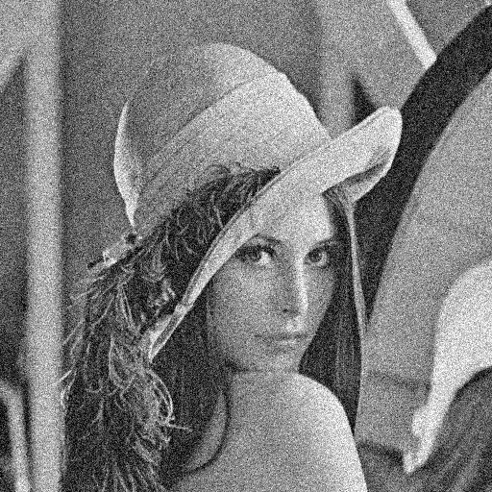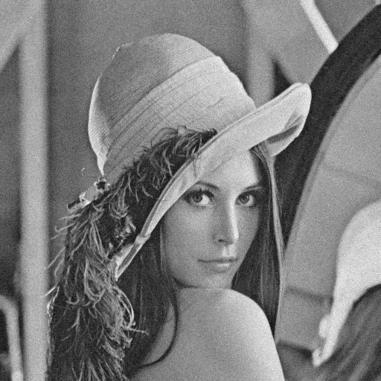 amplitude :10 amplitude :30

salt-and-pepper noise

threshold :0.05 threshold :0.1

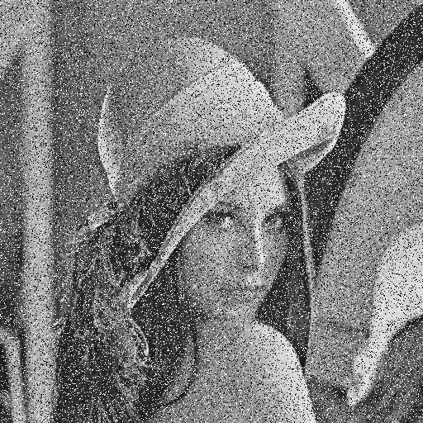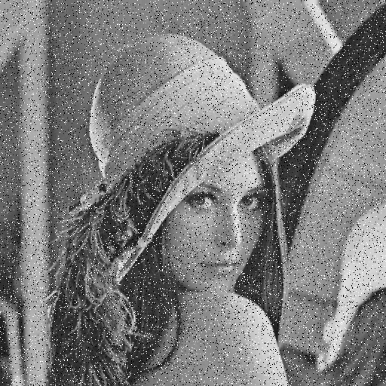

Part 2 additive white Gaussian noise amplitude : 10

Box filter 3x3 Box filter 5x5

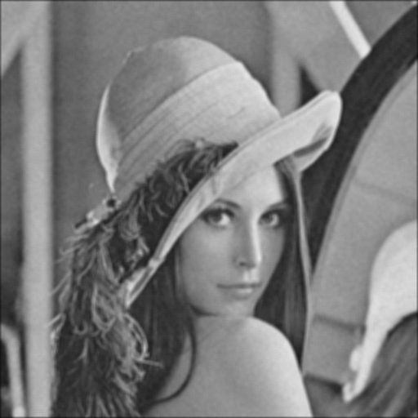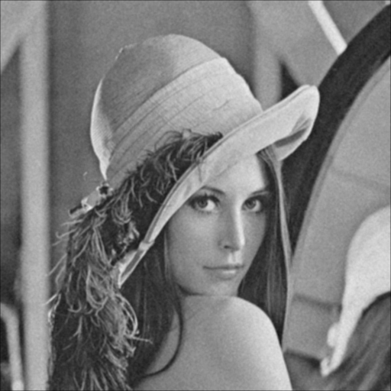

median filter 3x3 median filter 5x5

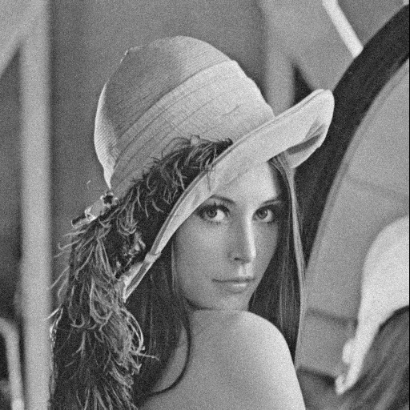

Opening then closing Closing then opening

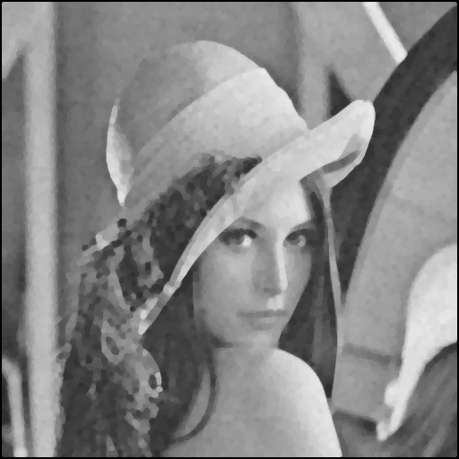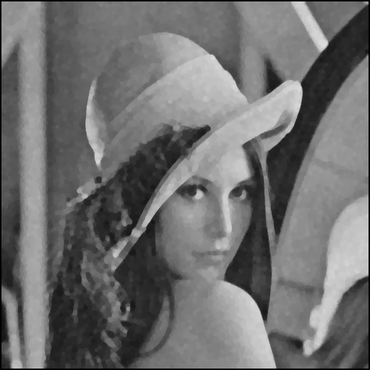

Part 3 additive white Gaussian noise amplitude : 30

Box filter 3x3 Box filter 5x5

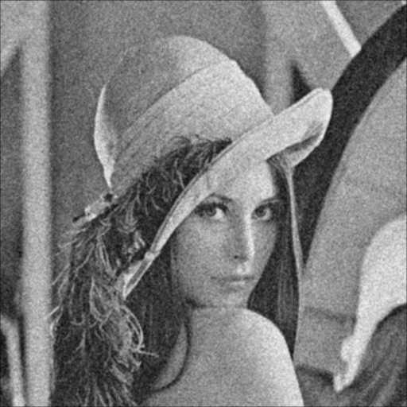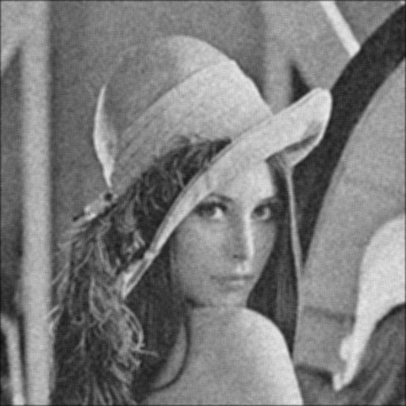

median filter 3x3 median filter 5x5

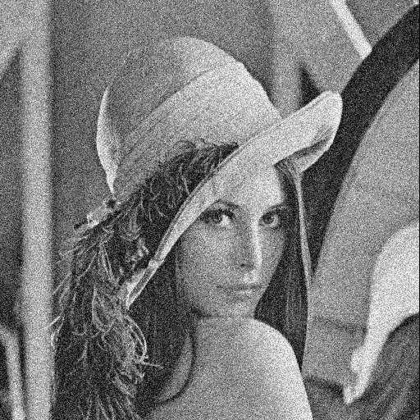

Opening then closing Closing then opening

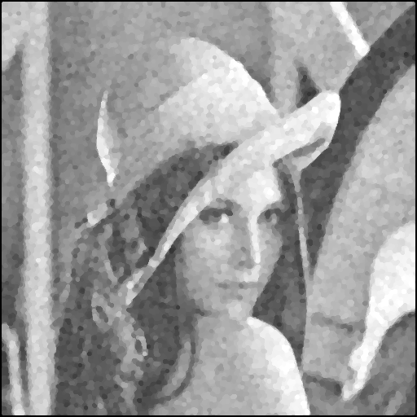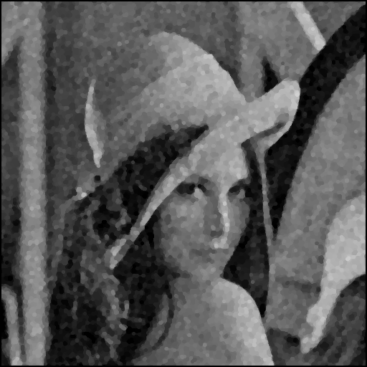

Part 4 salt-and-pepper noise threshold 0.05

Box filter 3x3 Box filter 5x5



median filter 3x3 median filter 5x5



Opening then closing Closing then opening

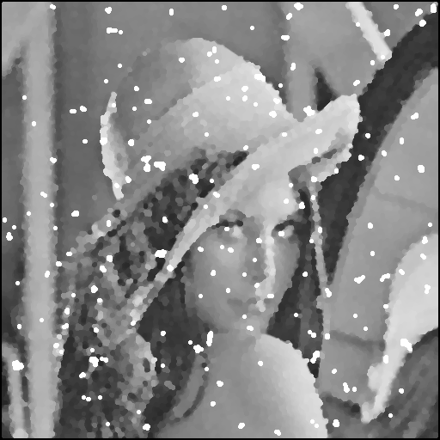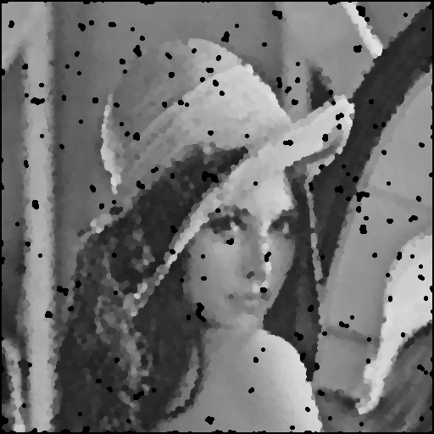

Part 5 salt-and-pepper noise threshold:0.1

Box filter 3x3 Box filter 5x5



median filter 3x3 median filter 5x5



Opening then closing Closing then opening

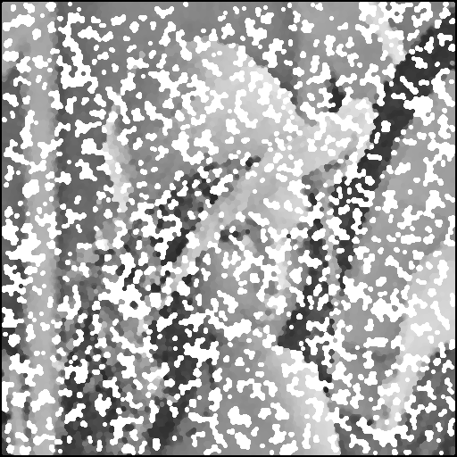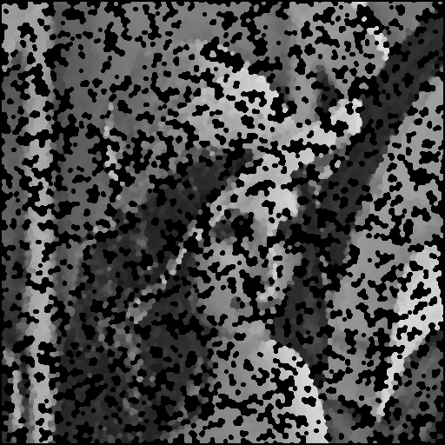

3 SVR

|  |  |  |  |  |  |  |
| --- | --- | --- | --- | --- | --- | --- |
|  | Box 3x3 | Box 5x5 | Median 3x3 | Median5x5 | Open then close | Close then open |
| Gaussian :10 | 17.3 | 14.8 | 17.1 | 13.4 | 8.82 | 7.62 |
| Gaussian :30 | 12.4 | 13.7 | 11.9 | 9.3 | 8.64 | 6.5 |
| Salt&pepper:0.05 | 8.9 | 11.4 | 18.4 | 13.8 | 5.3 | 4.51 |
| Salt&pepper:0.1 | 6.3 | 8.6 | 14.3 | 11.8 | -2.7 | -4.6 |